**IF YOU OBSERVE THE FOLLOWING:**

* Pain that radiates to the lower abdomen.
* Pain that comes in waves and fluctuates in intensity.
* Pain on urination.
* Pink, red or brown urine.
* Cloudy or foul-smelling urine.
* Nausea and vomiting.
* It may be initial signs of **kidney stone.**

**KIDNEY STONES** are hard, pebble-like pieces of material that form in one or both of your kidneys when high levels of certain minerals are in your urine. Kidney stones are solid accumulations of material that form in the tubal system of the kidney.

Kidney stones causeproblems when they block the flow of urine through or out of the kidney.  Kidney stones vary in size and shape. They may be as small as a grain or as large as a pea. Rarely, some kidney stones are big as golf balls. A kidney stone that’s gets stuck can block your flow of urine, causing severe pain or bleeding.

**What are the foods to be avoided for kidney stones?**

Avoid stone-forming foods: Beets, chocolate, spinach, rhubarb, tea, and most nuts are rich in oxalate, and colas are rich in phosphate, both of which can contribute to kidney stones. If you suffer from stones, doctor may advise you to avoid these foods or to consume them in smaller amounts.

**Guidelines to be followed in KIDNEY STONE**:

* Stay Hydrated-Drink plenty of fluids, particularly water.
* Eat less salt. Chinese and Mexican food, tomato juice, regular canned foods, and processed foods are often high in salt. Look for low-salt or unsalted products.
* Have only 2 or 3 servings a day of foods with a lot of calcium, such as milk, cheese, yogurt, oysters.
* Eat lemons or oranges, or drink fresh lemonade. Citrate in these foods prevents stones from forming.
* Eat a low fat diet.
* Avoid Vitamin-C supplements.

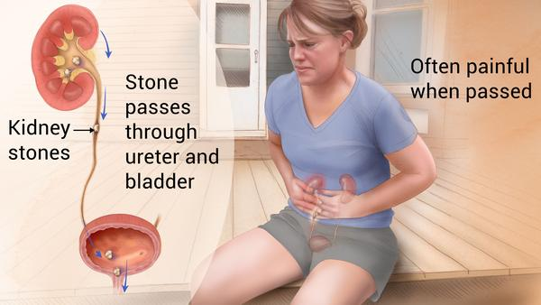 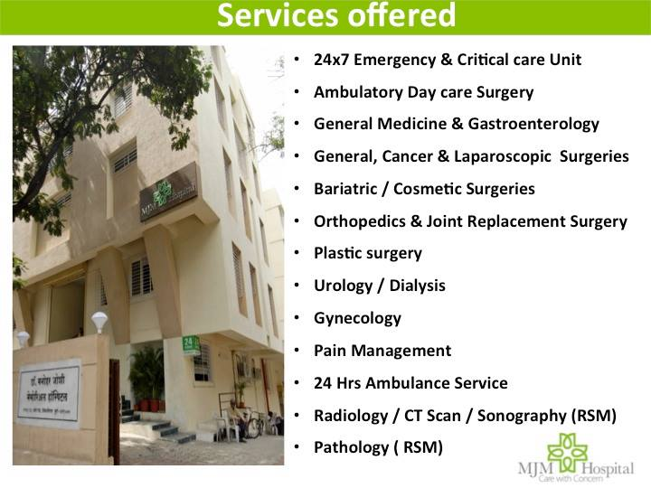

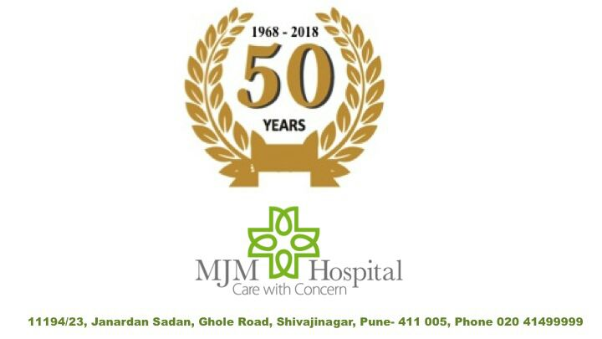

**MJM Hospital** runs **“KIDNEY STONE CLINIC”** in their hospital at Ghole Road, PUNE. The hospital is instrumental in reducing KIDNEY STONE problems in hundreds of patients.

For more details contact: 09769337236.